Myles J Sartor
Matthew Griffin
STAT100-0121
24 October 2023
Problem Set 6
1a. 450 – 526 / 120 = -0.63 = z-score (x – mean / standard deviation)
P (z < -0.63) = 0.2643, can also say P (x < 450)
1b.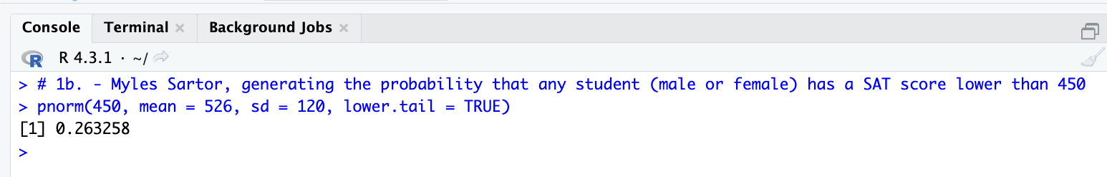
2. 450 – 536 / 124 = -0.69 = z-score
P (z < -0.69) = 0.2451, can also say P (x < 450)
3. 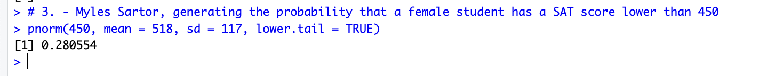
4a.
650 – 526 / 120 = 1.03 = z-score
P (z > 1.03) = 0.1515 (1 – 0.8485), can also say P (x > 650)
4b.
5. 630 – 526 / 120 = 0.87 = z-score
410 – 526 / 120 = -0.97 = z-score
P (410 < x < 630) = 0.6418 (0.8078 – 0.1660), can also say P (-0.97 < z < 0.87)
6. 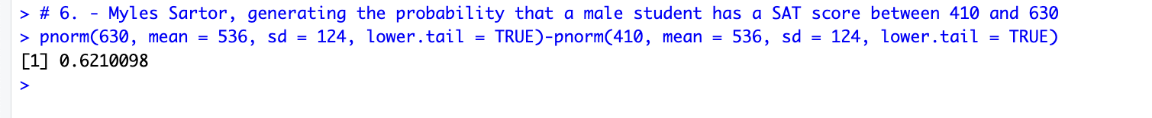
7a. 670 – 518 / 117 = 1.30 = z-score, P (z < 1.30) is the same as P (x < 670).
P (z < 1.30) = 0.9032 90.32 % 90 %
A female student scoring an SAT score of 670 would be in the 90th percentile.
7b. 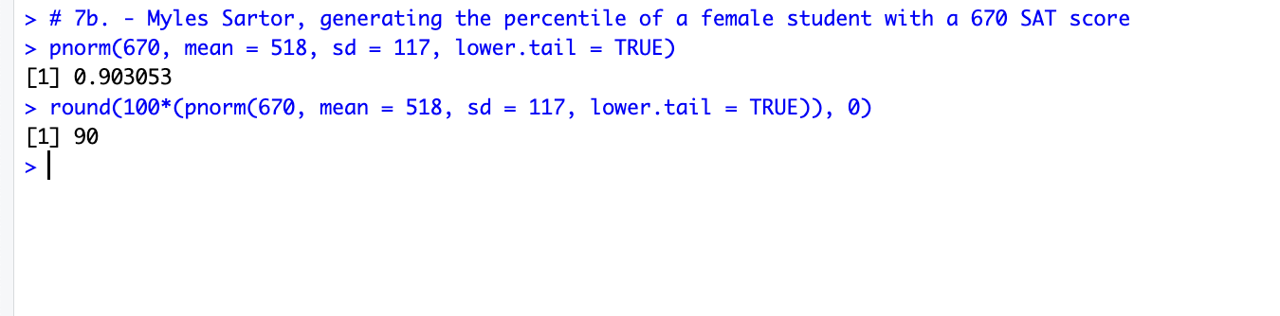
8.
9. It would be more likely for a male student with an SAT score of at least 730 to exist, rather than a female student with an SAT score of at least 710 to exist, since the probability for a male student with a score of at least 730 is 0.0594, and the probability for a female student with an SAT score of at least 710 is 0.0505. As you can see, 0.0594 > 0.0505, meaning that there is a more probable chance of the male student with at least a 730 SAT score existing than there is the female with at least a 710.
Shown Work:
Female: 710 – 518 / 117 = 1.64 = z-score
P (z > 1.64) = 1 – 0.9495 = 0.0505, same as saying P (x > 710)
Male: 730 – 536 / 124 = 1.56 = z-score
P (z > 1.56) = 1 – 0.9406 = 0.0594 , same as saying P (x > 730)
Probability for male greater than female, “at least” means greater than.

